**Documentation – Exporting a txt file from CATIA**

**Purpose:**

This document explains step by step creating a txt-file interface between CATIA and MatLab.  
The txt file has to be created once in the beginning. Then it works as a communication interface every time.  
If the existing txt file crashed or has a problem following needs to be done to export a new one.

**Exporting Process Step-by-Step:**

When existing txt-file crashed, all links to the CAD model need to be deleted before exporting a new file

1. **Deleting existing TXT file and link to Catia**
   1. Deleting existing txt-file that has an error or crashed
   2. Open CAD model
   3. Click Edit

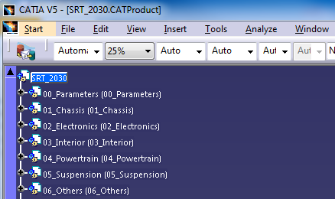

* 1. Click on Links
  2. Search for parameter table name “CAD_Model_Parameter_Table” and klick on it to activate Isolate button on the right

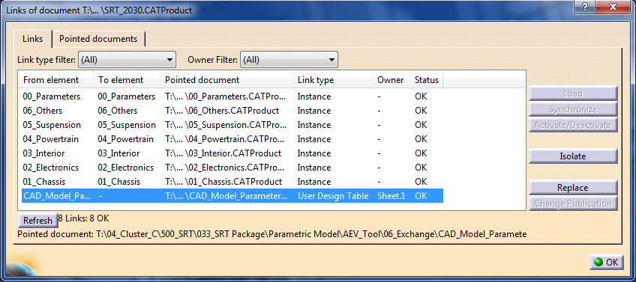

**3**

v

**4**

v

**2**

v

v

**1**

* 1. Click Isolate
  2. Click refresh – parameter table file should be gone now
  3. Close Links management centre
  4. Save CAD model and Close CATIA to avoid any errors

1. **Exporting a new txt file**
   1. Open CAD model
   2. Open design table Icon

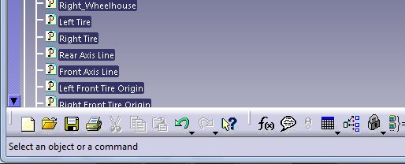

* 1. Name Design Table: “CAD_Model_Parameter_Table”, also Comment window

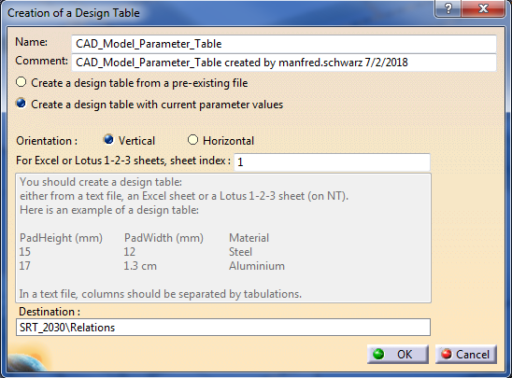

**4**

**3**

**2**

**1**

* 1. Klick “Create a design table with current parameter values
  2. Click Vertical
  3. Click OK
  4. Insert parameters to table in following order by clicking on arrow to.
     1. Parameters:

From *Parameter\l_overall* until *Parameter\h_window*

Confirm with arrow then filter materials

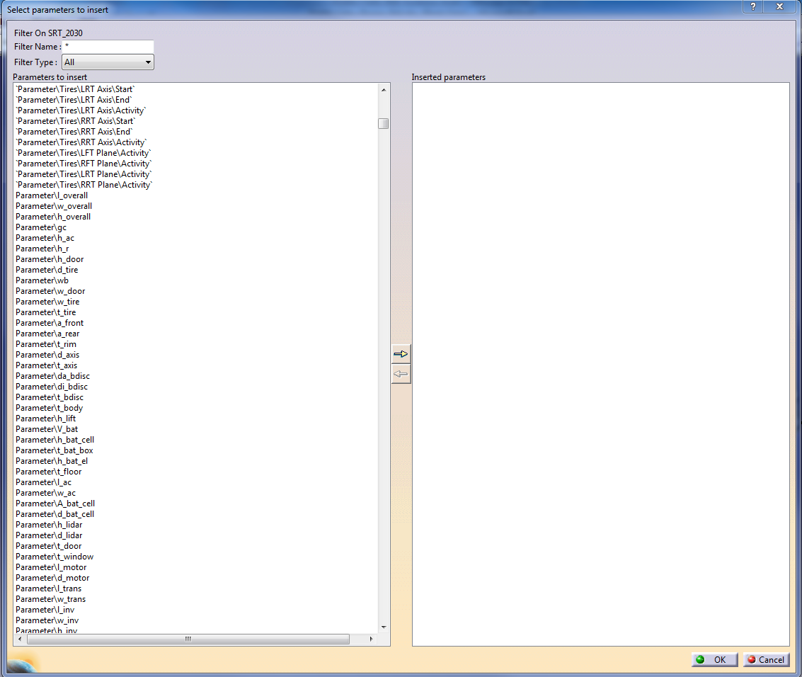

**1**

**2**

* + 1. Materials, all assigned ones:

From *01_001_Wheelhouse\Wheelhouse\Material*

until *05_010_Air Compressor\ Air Compressor\Material*

Confirm with arrow then filter layout

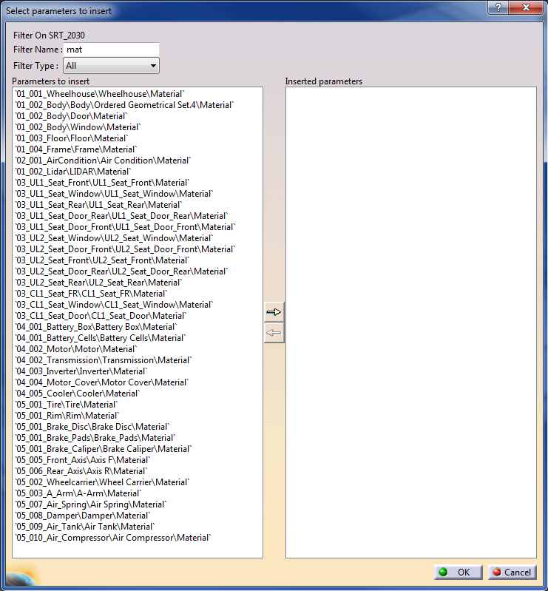

**3**

**2**

**1**

* + 1. Layouts:
* *03_Interior\03_001_Urban_Layout_1\ Component Activation State*
* *03_Interior\03_002_Urban_Layout_2\ Component Activation State*
* *03_Interior\03_003_Coach_Layout\ Component Activation State*

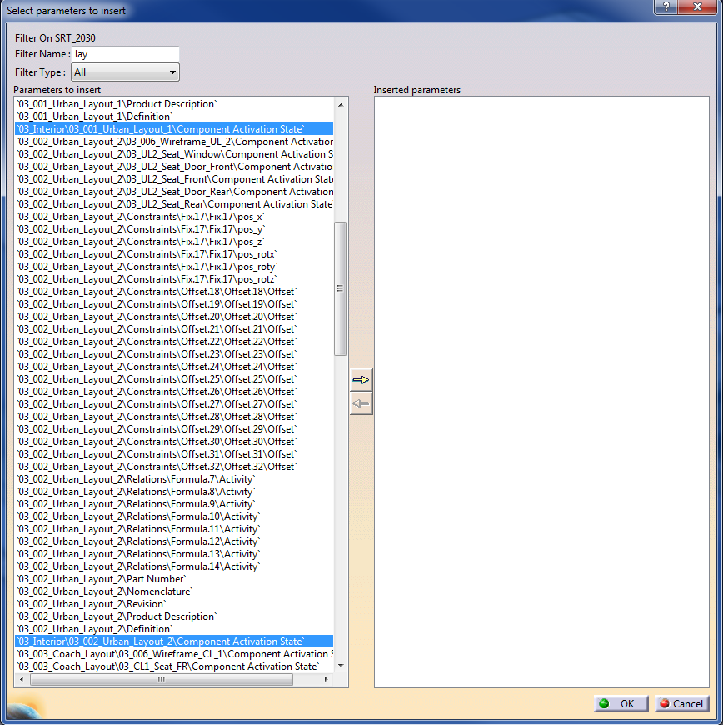

**3**

**2**

**1**

* + 1. Seats:

No window seat configuration

UL1 and UL2: only front rear, door rear and door front

Coach: only door

In total 9 seating configurations

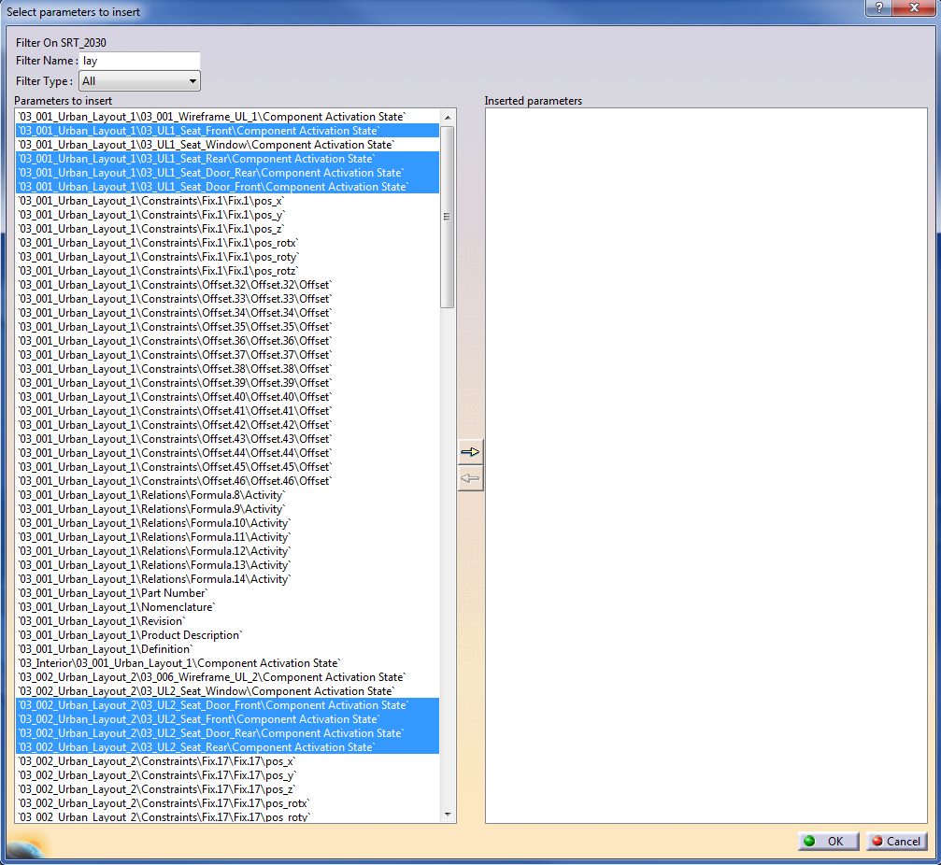

**2**

**1**

**3**

* + 1. Pattern (only UL1 and UL2):

No window pattern configuration, only front rear, door rear and door front

In total 8 patterns

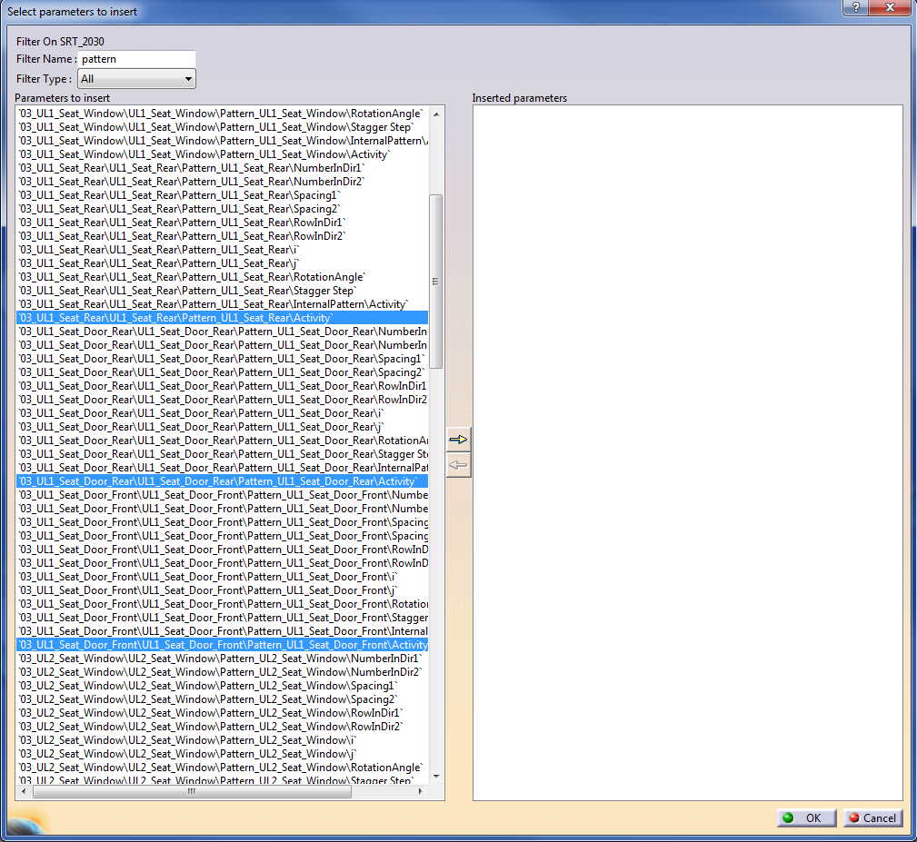

**4**

**2**

**1**

**3**

* 1. Drivetrain Configurations
     1. Drivetrain Activation: *Center Rear* and *Dual All*

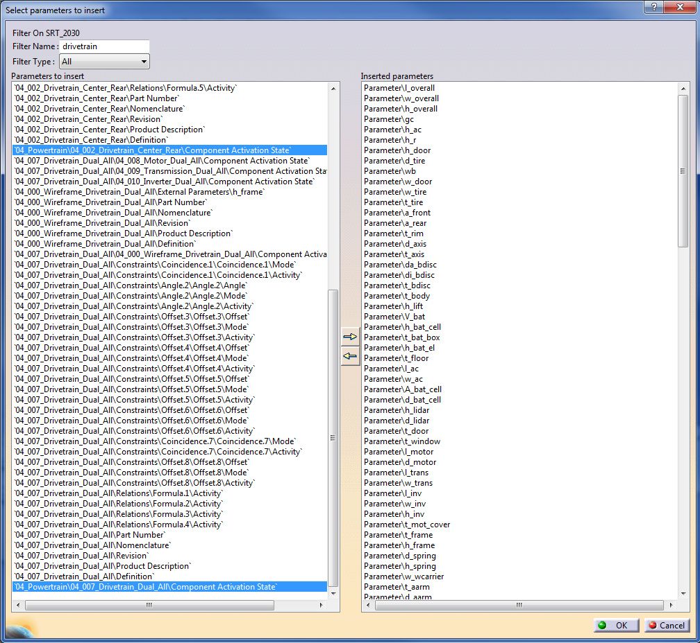

**3**

**2**

**1**

* + 1. Mirror Activation Drivetrain and Cooler for All Wheel Drive

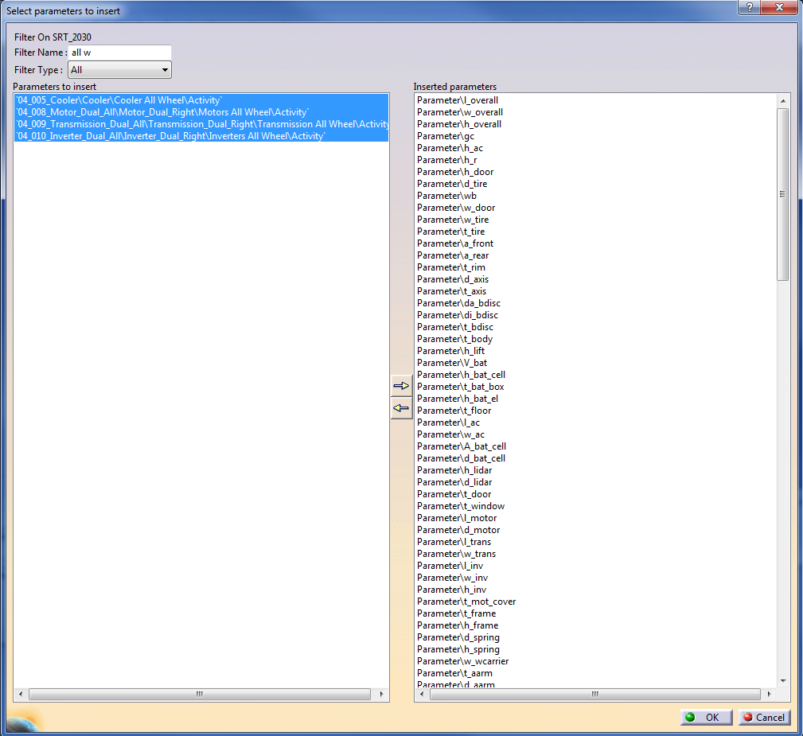

**2**

**3**

**1**

* 1. Ramp and Street
     1. *Ramp In* and *Ramp Out Component Activation State*

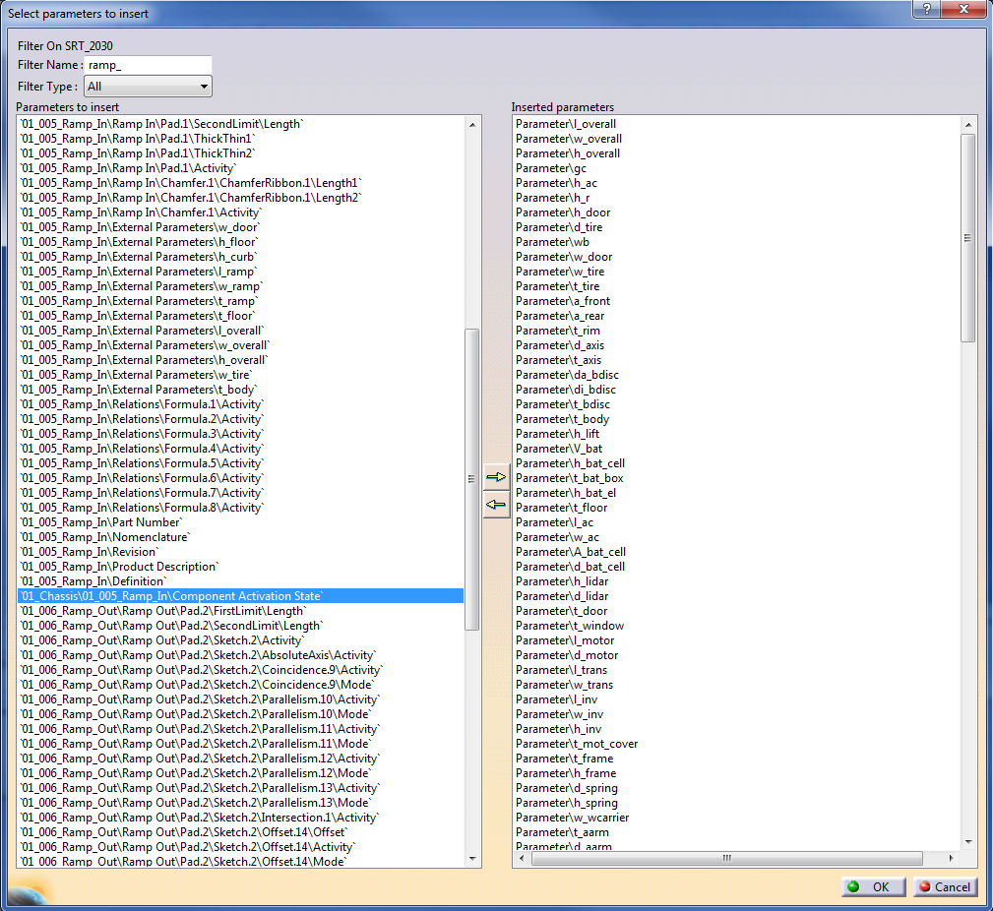

**3**

**2**

**1**

* + 1. Street Activation

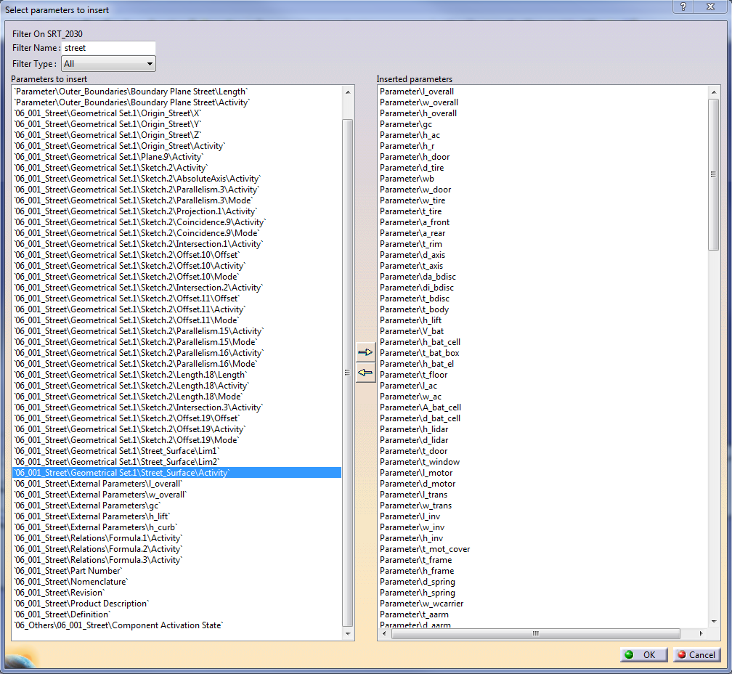

**4**

**3**

**2**

**1**

* 1. After selecting all 7 sets of parameter, clicking OK

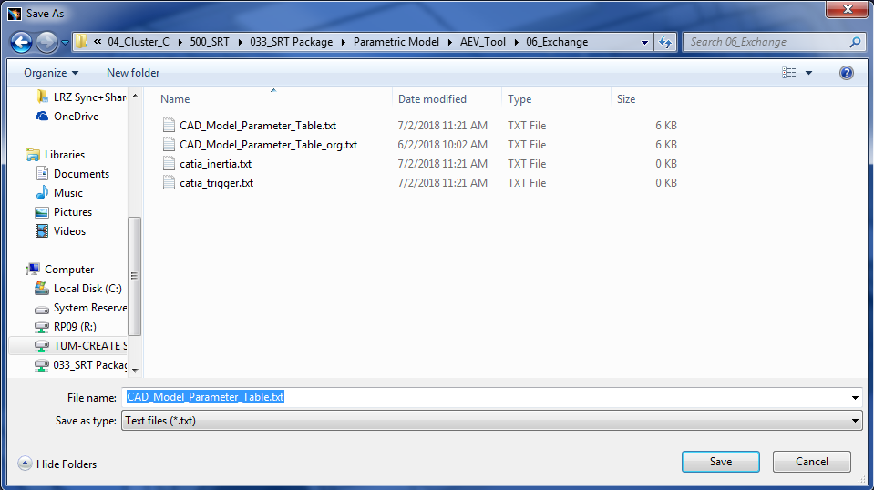

**3**

**2**

* **2**

**1**

* 1. Select file type: txt
  2. Select right folder path to save file
  3. Click save

1. Save CAD model in CATIA
2. Done! ☺

**The order of exporting the parameters is very important, because the list and the order of parameters is implemented in the Matlab code of the GUI (Update Parameters,…)**

**When adding additional parameters, layouts and materials the order of parameters have to be adapted in every code section a parameter is called from the txt file!**